Project 1.C

- Project Description
Figure 1 shows an ER diagram for University database. This is the same in Project 1.A and 1.B.

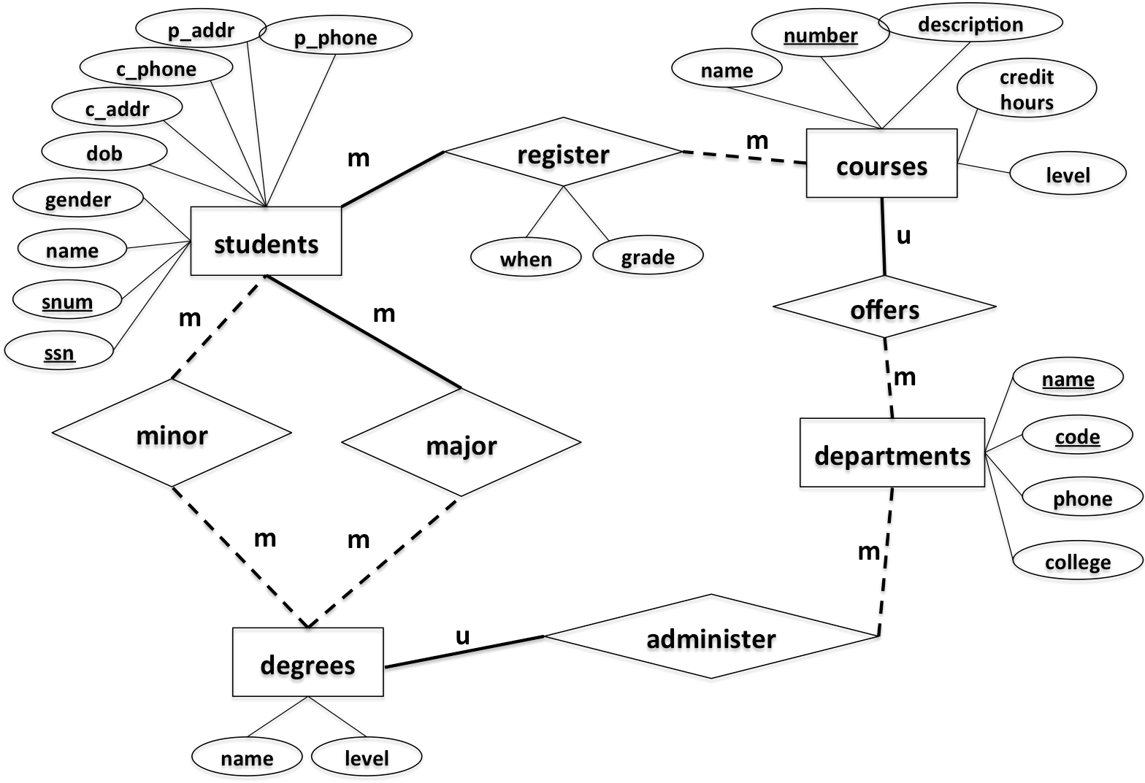
Figure 1. ER-diagram
This project is to implement the above design using a relational data model. Specifically, you are asked to write the following JavaServer Pages (JSP).

- CreateTables.jsp and CreateTablesResult.jsp [Points: 15]
CreateTables.jsp
This web page has one submit button (See Figure below). When clicking the button, it creates the following tables and redirect to CreateTablesResult.jsp. Those seven tables are:
- students
  - Attribute, type and length: snum: integer, ssn: integer, name: varchar(10), gender: varchar(1), dob: datetime, c_addr: varchar(20), c_phone: varchar(10), p_addr: varchar(20), p_phone: varchar(10)
  - Primary key: snum
  - Candidate key: ssn
  - Foreign key: N/A
- departments
  - Attribute, type and length: code: integer, name: varchar(50), phone: varchar(10), college: varchar(20)
  - Primary key: code
  - Candidate key: name
  - Foreign key: N/A
- degrees
  - Attribute, type and length: name: varchar(50), level: varchar(5), department_code: integer
  - Primary key: name, level
  - Candidate key: N/A
  - Foreign key: department_code refers to code in table departments
- courses
- Attribute, type and length: number: integer, name: varchar(50), description: varchar(50), credithours: integer, level: varchar(20), department_code: integer
- Primary key: number
- Candidate key: name
- Foreign key: department_code refers to code in table departments
- register
- Attribute, type and length: snum: integer, course_number: integer, when: varchar(20), grade: integer
- Primary key: snum, course_number
- Candidate key: N/A
- Foreign key: snum refers to snum in table students, course_number refers to number in table courses
- major
- Attribute, type and length: snum: integer, name: varchar(50), level: varchar(5)
- Primary key: snum, name, level
- Candidate key: N/A
- Foreign key: snum refers to snum in table students, name & level refer to name & level in table degrees
- minor
- Attribute, type and length: snum: integer, name: varchar(50), level: varchar(5)
- Primary key: snum, name, level
- Candidate key: N/A
- Foreign key: snum refers to snum in table students, name & level refer to name & level in table degrees
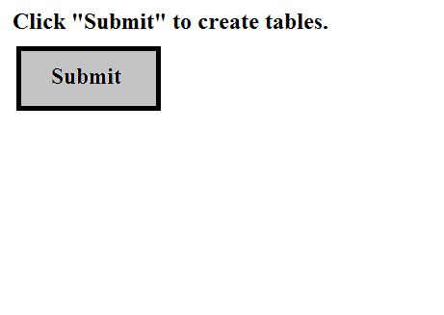
Figure 2: Example of CreateTables.jsp
CreateTablesResult.jsp
This page will display a result of tables creation (See Figure below).
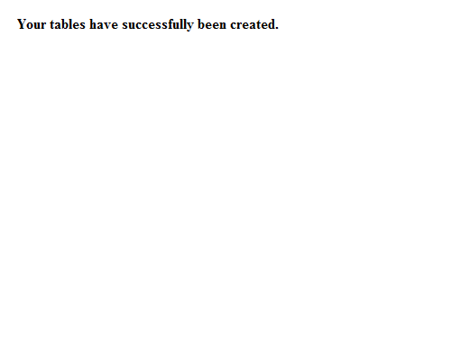
Figure 3: Example of CreateTablesResult.jsp

- InsertRecords.jsp and InsertRecordsResult.jsp [Points: 15]
InsertRecords.jsp
A web page has one submit button (See Figure below). When clicking the button, your web page must insert data records based on entered SQL syntax. Finally, it will redirect the user to InsertRecordsResult.jsp. Those data records are:

- students

snum | ssn | name | gender | dob | c_addr | c_phone | p_addr | p_phone
1001 | 654651234 | Randy | M | 2000/12/01 | 301 E Hall | 5152700988 | 121 Main | 7083066321
1002 | 123097834 | Victor | M | 2000/05/06 | 270 W Hall | 5151234578 | 702 Walnut | 7080366333
1003 | 978012431 | John | M | 1999/07/08 | 201 W Hall | 5154132805 | 888 University | 5152012011
1004 | 746897816 | Seth | M | 1998/12/30 | 199 N Hall | 5158891504 | 21 Green | 5154132907
1005 | 186032894 | Nicole | F | 2001/04/01 | 178 S Hall | 5158891155 | 13 Gray | 5157162071
1006 | 534218752 | Becky | F | 2001/05/16 | 12 N Hall | 5157083698 | 189 Clark | 2034367632
1007 | 432609519 | Kevin | M | 2000/08/12 | 75 E Hall | 5157082497 | 89 National | 7182340772

- departments

code | name | phone | college
401 | Computer Science | 5152982801 | LAS
402 | Mathematics | 5152982802 | LAS
403 | Chemical Engineering | 5152982803 | Engineering
404 | Landscape Architect | 5152982804 | Design

- degrees

name | level | department_code
Computer Science | BS | 401
Software Engineering | BS | 401
Computer Science | MS | 401
Computer Science | PhD | 401
Applied Mathematics | MS | 402
Chemical Engineering | BS | 403
Landscape Architect | BS | 404

- major

snum | name | level
1001 | Computer Science | BS
1002 | Software Engineering | BS
1003 | Chemical Engineering | BS
1004 | Landscape Architect | BS
1005 | Computer Science | MS
1006 | Applied Mathematics | MS
1007 | Computer Science | PhD

- minor

snum | name | level
1007 | Applied Mathematics | MS
1005 | Applied Mathematics | MS
1001 | Software Engineering | BS

- courses

number | name | description | credithours | level | department_code
113 | Spreedsheet | Microsoft Excel and Access | 3 | Undergraduate | 401
311 | Algorithm | Design and Analysis | 3 | Undergraduate | 401
531 | Theory of Computation | Theorem and Probability | 3 | Graduate | 401
363 | Database | Design Principle | 3 | Undergraduate | 401
412 | Water Management | Water Management | 3 | Undergraduate | 404
228 | Special Topics | Interesting Topics about CE | 3 | Undergraduate | 403
101 | Calculus | Limit and Derivative | 4 | Undergraduate | 402

- register

snum | course_number | when | grade
1001 | 363 | Fall2020 | 3
1002 | 311 | Fall2020 | 4
1003 | 228 | Fall2020 | 4
1004 | 363 | Spring2021 | 3
1005 | 531 | Spring2021 | 4
1006 | 363 | Fall2020 | 3
1007 | 531 | Spring2021 | 4
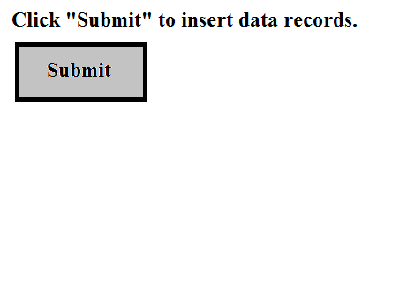
Figure 4: Example of InsertRecords.jsp
InsertRecordsResult.jsp
This page will display a result of records insertion (See Figure below).
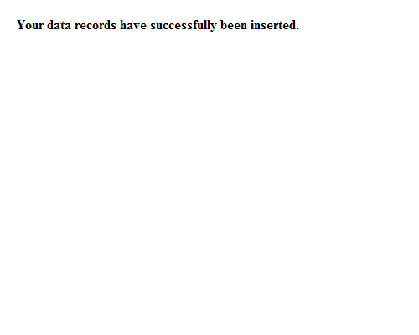
Figure 5: Example of InsertRecordsResult.jsp

- Query.jsp, QueryResult1.jsp, QueryResult2.jsp, QueryResult3.jsp [Points: 55]
Query.jsp
A web page has THREE buttons (See Figure below). When clicking any button, your web page must query data records based on corresponding query. Finally, it will redirect the user to either QueryResult1.jsp or QueryResult2.jsp or QueryResult3.jsp based on corresponding query to show query results. Those three queries are:
  - The student number and ssn of the student whose name is "Becky"
  - All degree names and levels offered by the department of Computer Science
  - The course numbers and names of all courses offered by either Department of Computer Science or Department of Landscape Architect.
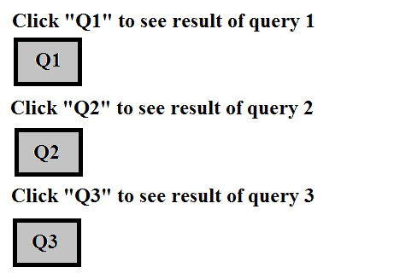
Figure 6: Example of Query.jsp
QueryResult1.jsp, QueryResult2.jsp, QueryResult3.jsp
This page will display a result of corresponding query (See Figure below).
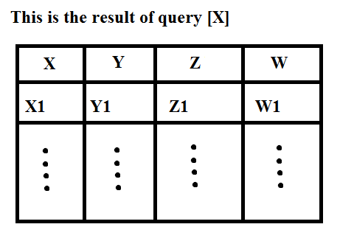
Figure 7: Example of QueryResultX.jsp
- ModifyRecords.jsp and ModifyRecordsResult.jsp [10]
ModifyRecords.jsp
A web page has one submit button (See Figure below). When clicking, your web page must modify a data record. Finally, it will redirect the user to ModifyRecordsResult.jsp. This is a modification:
- Change the name of the student with ssn = 746897816 to Scott
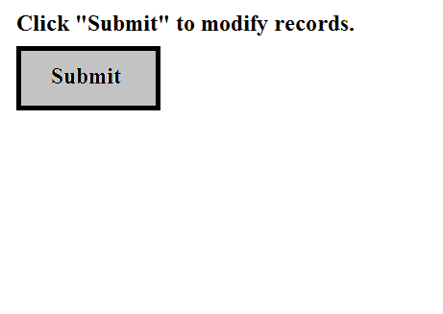
Figure 8: Example of ModifyRecords.jsp
ModifyRecordsResult.jsp
This page will display a result of record modification (See Figure below).
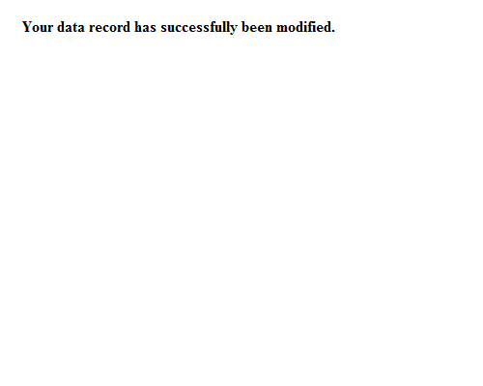
Figure 9: Example of ModifyRecordsResult.jsp

Submission Instruction
Upload all JSP files (CreateTables.jsp, CreateTablesResult.jsp, InsertRecords.jsp, InsertRecordsResult.jsp, Query.jsp, QueryResult1.jsp, QueryResult2.jsp, QueryResult3.jsp, ModifyRecords.jsp, and ModifyRecordsResult.jsp) to your account in Canvas.

- Set up a local working environment using Eclipse
SSG is supposed to set up a working environment for us. However, they are not helping anything yet. So let’s set up a local working environment. Specifically, you follow these steps.
  - Make sure that you have Java JDK installed in your computer, if not, you can get Java JDK at http://www.oracle.com/technetwork/java/javase/downloads/index.html
(same as project 1B)
  - Download and install Eclipse IDE (same as project 1B)
  - Download and install Connector J at https://dev.mysql.com/downloads/connector/j/
(same as project 1B)
  - Download Tomcat Server (Zipped file) at https://tomcat.apache.org/download-10.cgi#10.0.2 and unzip it to your preferred directory.

- Set up Tomcat Server and Create Dynamic Web Project in Eclipse
  - Create new Server in Eclipse by go to “New > Server > Server”, then, click “Next”.
  - Select “Apache->Tomcat v10.0 Server”, then, click “Next”.

  - Click “Browse…”, then, select the directory that you unzipped Apache Tomcat Server. Click “Finish”.
  - Create new Dynamic Web Project by go to “File > New > Other”, then select Dynamic Web Project under “Web” folder.

  - Specify Project name and Target runtime (Tomcat server that installed in your Eclipse at step 3). Click “Finish”.
  - You will get the Project Explorer like this:
  - Add Connector J JAR file to your build path by right-click at your project and select “Build Path > Configure Build Path”.
  - Select Libraries tab and click “classpath->Add External JARs”. Go to the directory that you stored Connector J JAR file and select it. Then click “Apply and close”.
  - Next, go to that directory again and COPY your Connector J JAR file manually.
  - Go to “[Your Project Folder]\WebContent\WEB-INF\lib\” and paste Connector J JAR file to that folder.
- Example of JSP Codes
In order to create JSP page, follow these steps:
  - Right-click at WebContent folder (in Project Explorer) and select “WebContent > New > JSP File”.
  - Specify the name of your new JSP file and click “Finish”.

  - Next, in order to connect to database, you need to have these statements in your JSP code:
    - To import necessary libraries:
    - To establish a JDBC connection:

- To select data from database:
- To insert/update/delete data:
- To get value from HTML form
  - Please note that JSP page consists of both HTML code and Java code. Every time you write any Java code inside JSP page, you have to wrap all your Java codes inside the scripting delimiter:

<% --- Your Java Code ---%>

- Tutorial
  - This page shows you how to create and run simple JSP application in Eclipse: http://www.srccodes.com/p/article/2/JSP-Hello-World-Program-using-Eclipse-IDE-and-Tomcat-web-server
  - This page shows you how to use “Form” to retrieve values from any control (textbox, check box, etc.) and send those values to another JSP page: http://www.tutorialspoint.com/jsp/jsp_form_processing.htm

